Temperature Sensor

The temperature sensor we have been able to get is the LM335. The LM335 is in a basic form a diode. For every kelvin degree increase in temperature the voltage increases by 10mv. The input pin of the Arduino UNO has a sensitivity of 5mv, which means that we are able to read a temp variation of 0.5 kelvin.

The Arduino input pin reading is given in a scale of 0-1024 for input of 0-5 v, this means that every reading of 1 represents 0.004882812V or 5v/1024. So the first thing that we have done is convert the pin reading to voltage reading by multiplying the reading by 0.004882812V. After the voltage readings are read, then we convert them to degree kelvin, this is done by the relationship that 10mv is 1kelvin, this means that a voltage reading of 1 means 100kelvin.

When we tested the sensor against a mercurial temperature sensor, we observed that the sensor was reading a few degrees (specifically 2.5 degrees) higher than what it actually is. This is due to the current running in the diode increasing its temperature, this can be done by reducing the current running in the sensor by using a different resistor value or by using the Arduino to correct for this.

For the time being we have opted to use the Arduino to correct this until we have a good resistor chosen.

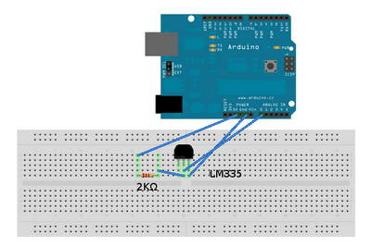

Humidity Sensor

Due to the lack of access to a professional grade humidity sensor in the market area, we have decided to create our own humidity sensor from gypsum. We first herd of this from Mr. Daniel who suggested that we use this if we couldn’t obtain a manufactured one.

The way the gypsum humidity sensor works is, by inserting two iron rods that are disconnected, into the gypsum and then using a cast to create a mold with the iron rods in it.

The gypsum can absorb water, and as it absorbs water the resistance between the rods decrease until the gypsum saturates and reaches a resistance of water. And as the air gets dry the moisture in the gypsum gets released, and the resistance increases.

We have observed the variability of the humidity sensor, by using a stove to reduce the moisture, when the gypsum has approximately 0 moisture the resistance is around 15-20 MΩ, and using a tea pot to create a very high humid environment at which point the resistance reduced to almost water resistance level.

Rain Flow Sensor

This sensor is used to measure the amount of rain that is falling from the sky at the moment. It will measure the flow of rain in discrete values.

The way we are thinking of implementing this sensor is by using a water bottle and a couple of wires. The first thing that we need to do is cut the neck on the water bottle, then insert two wire on opposite sides of the bottle, and we will have this pairs at different levels on the bottle. Then we will drill a hole at every level, to let the water from the rain to flow out. What this means that for each pairs of wires to be connected the rain should be greater than the drilled hole, as we go to a higher level the drilled area is hole number increases so a higher flow will be required.

We have yet to test and calibrate the hole sizes required, but we are confident about being able to achieve this.